**Conversation Guide: Digital Health Modernization Discovery Research - Caregiver Group**

**Bold text identify the moderator’s questions.**

*Text in italics are Jen’s observations and interpretations of the participant.*

[Text in brackets are interpretations in participants’ direct quote.]

**Background (5 minutes)**

To get started, I’d like to get a little background information about you, and your experience with the VA.

1. **Can you tell me a little bit about yourself and the Veteran you care for?**

*Note that both caregiver and participant were on the call together. Have noted who was speaking.*

[Veteran]: I was in the Air Force for 8 years when I was medically retired. Then when I got real bad. I got sick in 2005, then they medically retired in 2008 and I got really sick in 2010 and that’s when I had to move in and my mom became my caregiver.

**Where are you located:**

[Veteran]: Texas.

**Tell us about you Mary/Caregiver:**

[Caregiver]: I am Mary. Tonya is my daughter, she lives here with her dad and I. We brought her back home in 2010 because she became totally paralyzed. So it took some extensive therapy, hard work, and prayers to get her to this point now.

1. **When did you step into the role of a caregiver?**

[Caregiver]: 2010.

**2008 when medically retired:**

[Veteran]:Yes**.**

1. **Do you [Caregiver] personally receive any benefits from the VA?**

[Caregiver]: Yes, I receive a stipend.

**Part of the caregiver program:**

[Caregiver]: Yes I am.

**When did you apply for that:**

[Caregiver]: I think it was in 2012.

**Do you remember how you heard of it and applied:**

[Caregiver]: Basically it was her doctor from the VA that got everything going.

**Did you work with another to apply:**

[Caregiver]: No, we just did it. Then they take all of the medical records and they go through it to decide what your level is from there. We did have a meeting with them yesterday.

**What about:**

[Veteran]: Just our annual where they check in to evaluate stuff.

**Meeting over video call:**

[Veteran]: Yes.

3**.a. What VA benefits does [Veteran] receive?**

[Veteran]: I get my healthcare there, some of my healthcare there.

[Veteran]: I get my benefits, my financial aid from there.

[Veteran]: They modified the house for us. They supply my wheelchair and modified my car.

[Caregiver]: That’s about it.

1. **Do you manage any of [Veteran's] VA benefits online?**

[Veteran]: Since COVID we do a lot online.

**Is that just appointments or other things:**

[Caregiver]: We do everything overall. Video chats, appointments, refill her medicine and make sure everything is taken care of.

[Veteran]: Since COVID we have gotten technically proficient.

[Caregiver]: I can’t take the chance of her going somewhere, or one of us bringing something back her, so basically we have to be isolated.

X.a. Where you went online for prescriptions or other things?

[Caregiver]: Express Scripts, My HealtheVet. Those are the two. My HealtheVet for the VA. Express Scripts for outside doctor.

Do you both use those websites:

[Caregiver]: It is primary me but she also does and sometimes. I will tell her to go.

**Between Express Scripts and My HealtheVet do you notice a difference or like something in one more than the other:**

[Caregiver]: I do prefer Express Scripts because you do get 90 days. Where as My HealtheVet is a 30 day supply for prescriptions.

[Veteran]: I like My HealtheVet for when she tells me to go tell my doctor stuff I can just quickly email them. I get frustrated waiting for 9 years on the phone. Especially down here, we go to the Denton COBC because the Dallas one is a little to far. We only go there [Dallas] for the specialist. To get ahold of the doctors in COBC the email is easy.

[Caregiver]: Yeah.

**If have a question for doctors is that normally you [Veteran]:**

[Veteran]: Yeah. Mom likes to give me those independent tasks.

**Other online tools when it comes to the VA:**

[Veteran]: There’s one other page that you go in and apply for benefits from the VA. We had to do it when we to get the car modified. My benefits? I don’t remember. I think it’s a link on my iPad.

[Veteran]: Mostly it’s My HealtheVet.

**Which device do you tend to use:**

[Veteran]: My mac.

**Use an iPad as well:**

[Veteran]: Yeah.

**Is this the website you are thinking of:**

*Moderator shares screen.*

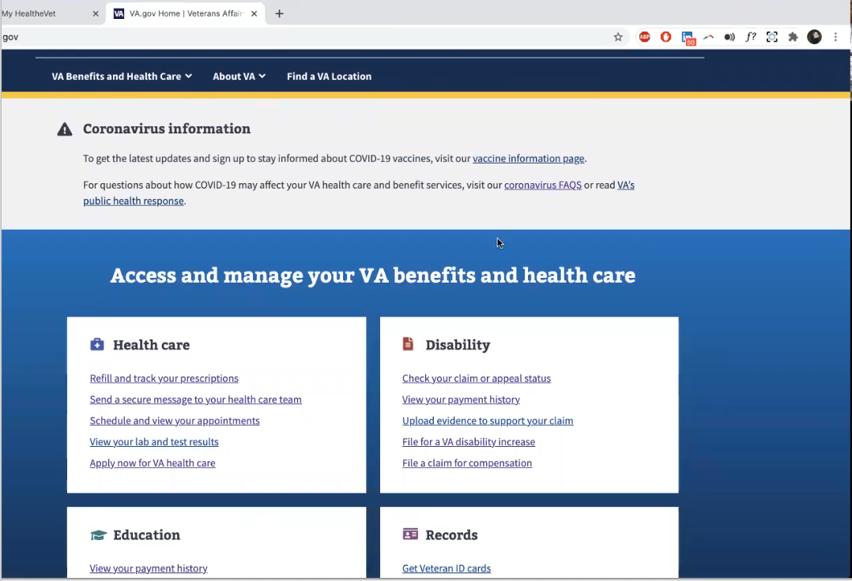

Moderator shows Participants [VA.gov](http://VA.gov) home page.

[Veteran]: Yes, that is just the VA main website. The one you go to find out.

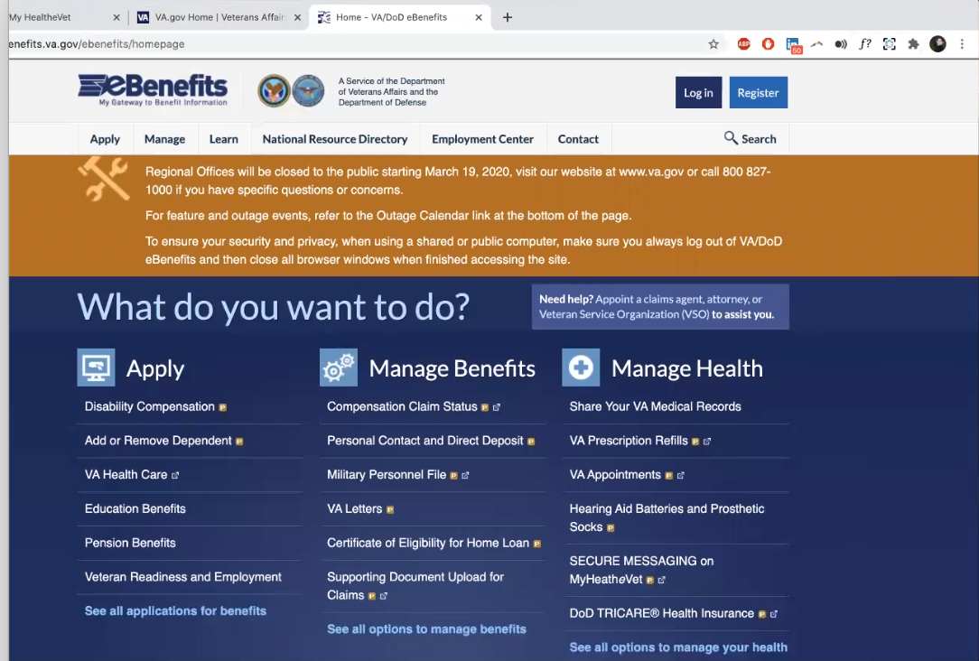

Moderator shows Participants Ebenefits home page.

[Caregiver]: Oh yes.

[Veteran]: Yeah. Yeah the ebenfits. That is the one I was talking about.

**You said you can go here to get your records or a medical sheet:**

[Veteran]: You can get the letter saying you have VA healthcare on there. You can check claim status and put in for new claims requests. I have never seen the manage health part so I guess it’s been awhile since I have been on.

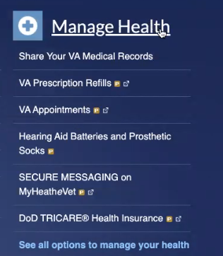

Participant is talking about Manage Health section of Ebenefits home page.

**You use My HealtheVet. Does this look familiar:**

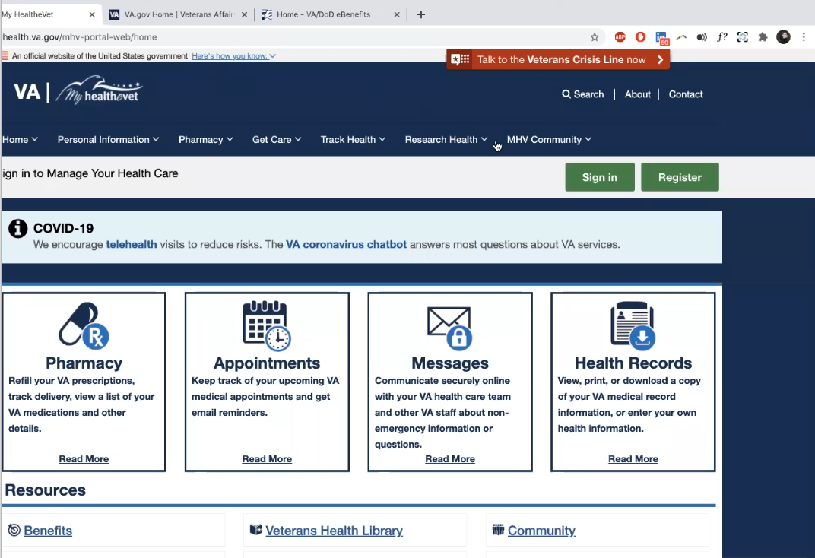

Moderator shows Participants My HealtheVet home page.

[Caregiver]: Yes, that is the one I use.

**I think [Veteran] said this is the main VA:**

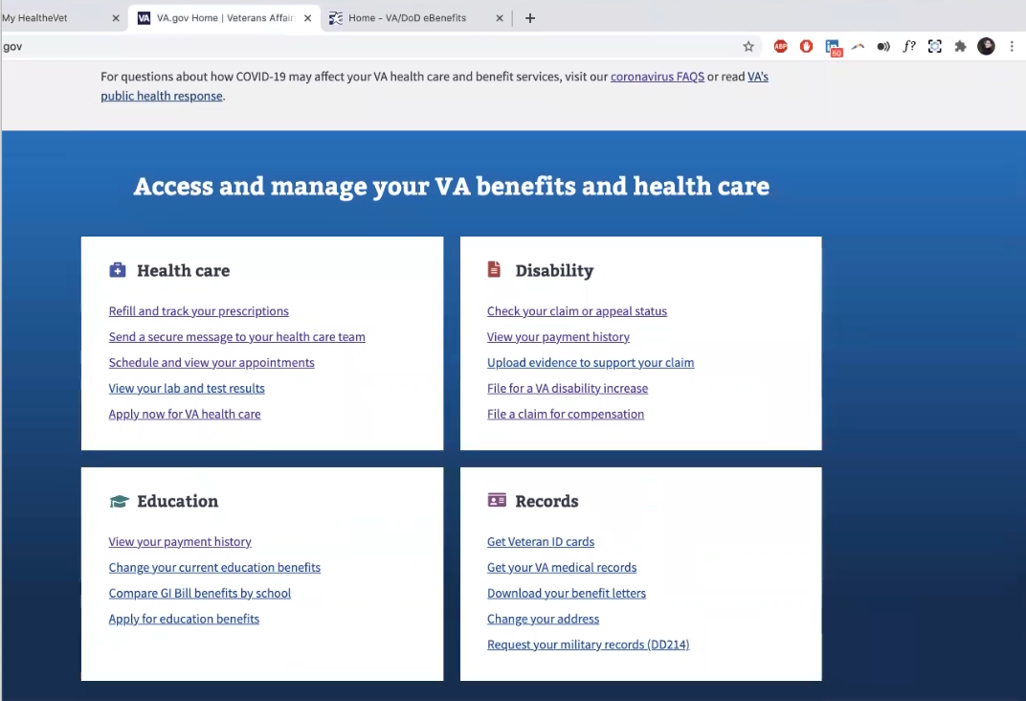

Moderator shows Participants [VA.gov](http://VA.gov) home page.

[Veteran]: Yeah

**Do you remember if you’ve used this for anything before:**

[Veteran]: At the very end of my claim process they started having this together, so I didn’t really use it for my claim status or anything. I had to use it to get some VA records I think.

[Caregiver]: I don’t really use it.

1. **Do you use any mobile apps to manage your health:**

[Veteran]: We tried the VA one where you can order your prescriptions but it was way too complicated. I couldn’t figure it out. So we went back to doing the website.

**Any apps outside of VA for your health care:**

[Veteran]: Basically we use the alarms for when I need to take medicine. Just the general phone apps. But there’s an app I think it’s through Walgreens where you can put all medicine. Both outside, insides, herbs, whatever you want. That way I always have the list of my medicine with me. And I can just print it off to provide to a new doctor or email it.

**Mental model of health at the VA (20 minutes)**

Now I’d like to hear about your experience first learning about VA benefits. **(10 minutes)**

1. **How did you learn about the health care available to [Veteran] through the VA, and what was the process of applying for and accessing those benefits?**

*Both Caregiver and Participant laugh at the question.*

[Veteran]: I did not. They told me to go check in with the VA and see you later.

[Veteran]: So I went and I walked into the VA I was like hey I’m here, and they were like thanks.

[Veteran]: It wasn’t until 2010 when I was paralyzed. They had just transferred me to the rehab facility, and my mom flew to where I was. And she was like you know there’s a VA two doors down.

[Veteran]: She walked in there and they told her if I had been assigned a doctor I could be in the VA right now. I didn’t know about being assigned a doctor. I had Tricare.

[Veteran]: So when they told my mom that, she was like [Veteran] just had a serve illness that they medically retired her for. She asked what to do. And they told her to have me come here. So my mom had have the people physically get me to the VA in a loner wheelchair, because we didn’t have one of our own, so I could meet with a doctor to get in the VA system.

[Veteran]: The first thing the doctor asked why I was out of the hospital. Because we were told we had to come here to get VA assistance. At the time I had Tricare but there was still a massive co-pay for medical bills. They were somewhat understanding but not very helpful.

[Veteran]: And once we were there they said they could get me a wheelchair but that was all the help they provided in the beginning.

[Veteran]: Then when transferring down to Houston they processing us out. And the VA in Virginia told us that they would process me in when I went to Houston.

[Veteran]: So basically I am going from one facility to another. That didn’t happen. The VA in Houston was like who are you again. It was going to be 6 months until they could get me into therapy.

[Caregiver]: It was a battle. The process was a battle getting settled in the VA system.

[Veteran]: My mom [Caregiver] didn’t even hear about the caregiver program until two years later.

**When you showed up in person, was that an in person application process:**

[Veteran]: It wasn’t really and application. Because I did that beforehand when I went to the VA.

[Caregiver]: I also went in to get her registered. She was given no instructions and with my husband being retired military, I knew what should have happened. So I questioned her why it didn’t and that was when I started to process her when she was in rehab.

[Caregiver]: In the initial first month when working with the VA was just getting it together. When it came to getting everything, her wheelchair, kinda that’s when the battle began. At first they didn’t even want to pay for a wheelchair.

**Do you want to tell me a bit about when the battle began:**

[Caregiver]: Like I said they didn’t want to pay for the wheelchair. We had got a wheelchair and that the company said the VA would pay for it. That’s how I got her home. Then we got a call saying they are coming to pick up the wheelchair. So I had to contact the VA and start a battle that way. Because I would have her home and no way to move her form one spot to the other.

[Caregiver]: Finally I got that settled and I brought her home to Houston. And then it was a battle to get her appointments. Like she said, 6 months. *Participant is referring to time wait time for appointments taking 6 months.*

[Caregiver]: Well she didn’t have 6 months to wait at that point. She was totally paralyzed. Barely breath on her own because she was on a ventilator. It was an all day battle for months on end.

[Caregiver]: We would leave at 5am and return at 7pm. That was pushing her all around the VA, if they didn’t see her they said we were basically just saying that. *Participant’s impression is they had to physically be at the VA to get expedited attention and care.*

[Caregiver]: I had to take her with me and push her around the VA. At that time if you weren’t forceful or loud you didn’t get anything accomplished. It’s sad to say. It’s very sad to say.

[Caregiver]: It is a matter of learning the tricks and trades which is sad and hard. I gotta admit. Because no one tells you what to do.

[Veteran]: It was a full time job times two for my mom. She’s trying to take care of me and getting me accustomed to this way of life new life. And she’s doing with while we’re in VA waiting to get ahold of somebody who may or may not be able to help us. Who may or may not be the right person. While I am sitting in the chair falling asleep and I can barely hold my head up. Like can you please just help us.

[Caregiver]: And it was a push chair which made it even harder for me. *Participant is talking about wheelchair.*

[Caregiver]: When I would ask for things that could help her life and mine, it was always, well she had a disease and this is for spinal cord injury. But her disease is in her spinal. *Participant seems to be referring to the combo of medical issues being classified by the VA as both military and non-military related.*

[Veteran]: We was told it would have been better to have been shot in the food than to come home from my deployment sick. Even though the military said it was service connected.

[Caregiver]: I can even tell you the doctors name. Dr. Sneed. She told my child that she needed to stop whining and complaining and get used to being in a chair.

[Veteran]: Her exact quote was - I need to get more use to staying in the wheelchair then trying to get out.

[Caregiver]: In front of a three year old. And she started crying because my daughter started crying. So I am carrying a three year old and I am crying and trying to push a wheelchair. As I started to go out, I’ll be honest, I thought of it and I was like she’s [doctor] going to tell this to somebody else. No, she’s [doctor] not going to get away.

[Caregiver]: So I left [Veteran] sitting there, put the baby [three year old] on her lap and I went back to her. And I let her have it in front of everyone. I still to this day remember the name, and face. Because if you do it to one Vet you will do it to all.

[Caregiver]: There were too many young Vets that were my daughters age that were complaining about not being able to get medical. If you would tell them about that I would appreciate it.

**Once you were back in Dallas at the VA, did it change:**

[Veteran]: We were in Houston first. And then we recently moved to Dallas. Oh my God is night and day. *Have heard from a few Veterans/Caregivers that location makes a big difference in care.*

[Veteran]: Totally different. When we got here it was welcoming arms. They practically knew we were coming. They asked what they help us with what could they gets us. We still had boxes in the house and they were doing construction in the house to make it more accessible.

[Caregiver]: This VA is much better. Much better. I understand it is smaller. Actually no, the main VA is in Dallas it’s not smaller but the outlets are smaller. There are a lot of veterans here. It’s just their work is faster

[Veteran]: They’re faster and they’re considerate. Personally I feel like they actually want to help you versus throwing up roadblocks. In Houston until you were in the in-club, we used to joke about, that you weren’t just getting the you need. And that wasn’t just me. That was other veterans.

[Caregiver]: You were always up against some type of roadblock. I mean I loved her doctor there. She would spend quality time with each patient. And he tried his best to get what they needed. So if I knew of something she needed he would really try but they would block down. They constantly told him no. And it wasn’t just for one vet it was for all of them.

[Caregiver]: Even when it came to her medication I had to fight them on it. Instead of giving her medication to ease her pain they her on hardcore meds and then sent her to a pain management because she was addicted.

[Veteran]: You [VA] forced me to be on this medicine. What are you talking about.

[Caregiver]: And they wouldn’t take her off. That again was a long time battle. So basically I started up taking her to out in town [non-VA doctors]. And then when we went back to them I would say she’s no longer on your meds. These are the meds she’s on.

**Out in town you mean outside the VA:**

[Caregiver]: Civilian doctors, yeah.

1. **How did you navigate that process of going outside the VA:**

[Veteran]: It started when our doctor, the really good one, he said you know you still have your Tricare and we both like lightbulb going off moment. By then I had Medicare care too. For being disabled. We just started going out and it was easy.

[Caregiver]: Just finding doctors. I had wonderful primary care so I started with him and then finding doctors qualified with her illness.

[Veteran]: We keep saying my illness. I have multiple sclerosis.

[Veteran]: The VA put the lead neurologist, the doctor in charge of figuring out what was going wrong, was a stroke doctor. They [VA] said all neurologists are the same. He had no clue and he admitted it. He said I don’t know why they assigned you to me when I deal with strokes. You have a disease, we call it MS [multiple sclerosis] but it came from being around the chemicals while you were deployed. I [VA neurologist] have a clue so why don’t you tell me what you need.

[Veteran]: So I would go to my outside neurologist and he tell me what I needed to be on and what I needed to do. And then I would go back to the VA neurologist and tell him what the outside doctor said and he put me on that.

*Both Participants laugh.*

[Caregiver]: Yes. That is how we handle things in order to get things done.

Now I’d like to ask you how you manage information and tasks related to [Veteran's] health care. For each one, talk me through the steps you’d take. If there is something that you go online to complete, I may ask you to share your screen so I can see what you would do. **(10 minutes)**

**Tasks** Moderator should prompt about device usage if participant mentions digital tools or resources.

* **How would you reach out to [Veteran's] VA care team if you had a question?**

[Caregiver]: The care team, I would go on the My HealtheVet and email them. If I didn’t want to go that route I would just call. Sometimes I just want to hear that voice.

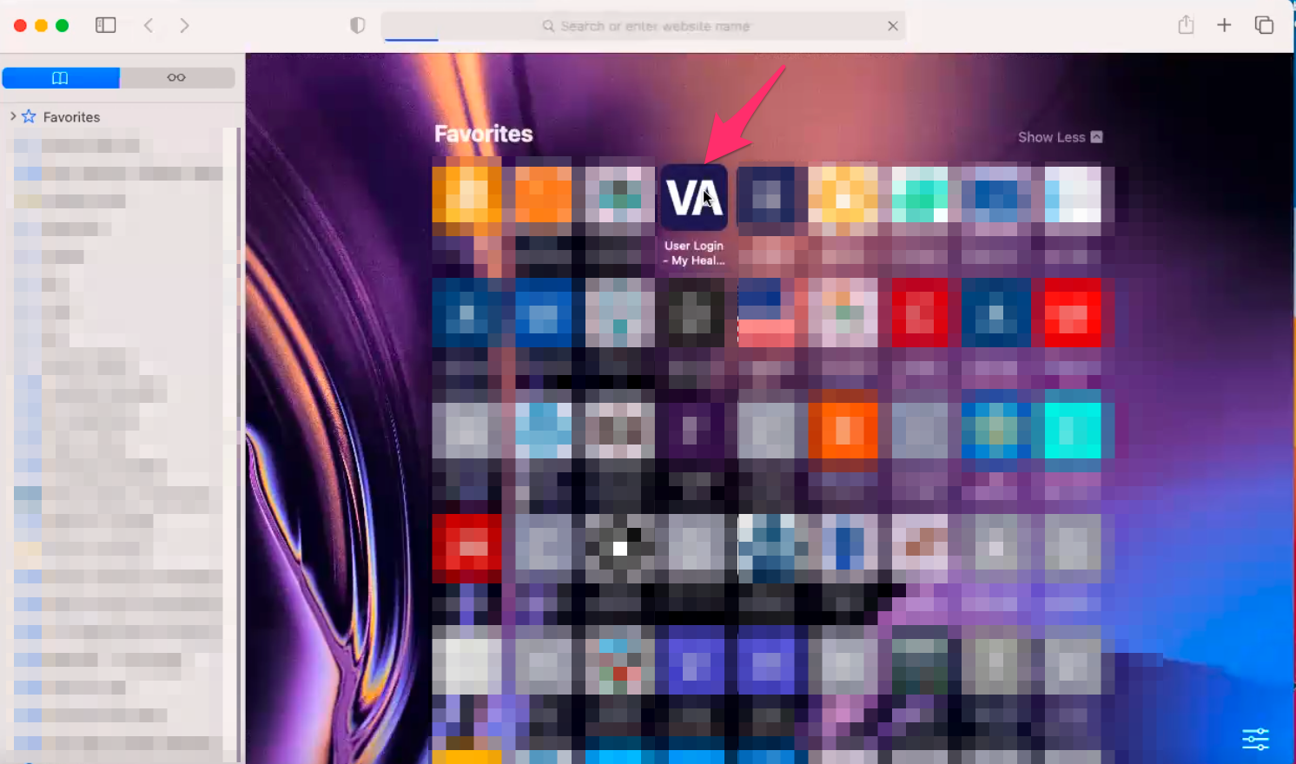

Veteran shares screen. Has User Login page on My HealtheVet site in Favorites in Safari.

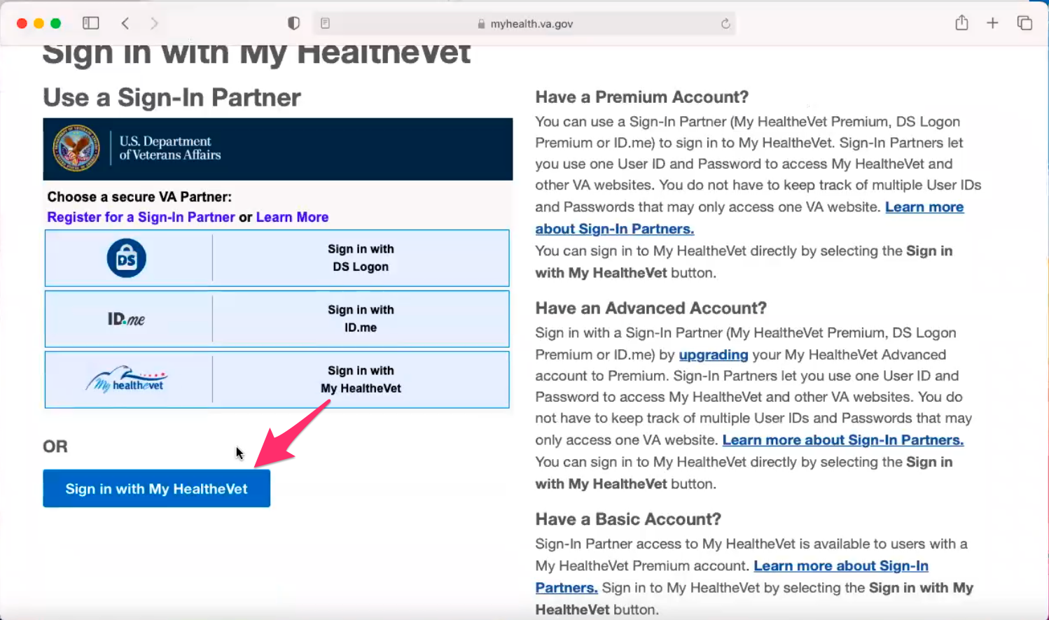

User Sign in page loads on My HealtheVet site. Veteran immediately scrolls down and clicks on blue “Sign in with My HealtheVet” button.

**How did you know how to sign in, I know there is couple on that page:**

[Veteran]: Yeah there is a lot. I just go by habit with what they had before they had those options. You just signed in with My HealtheVet.

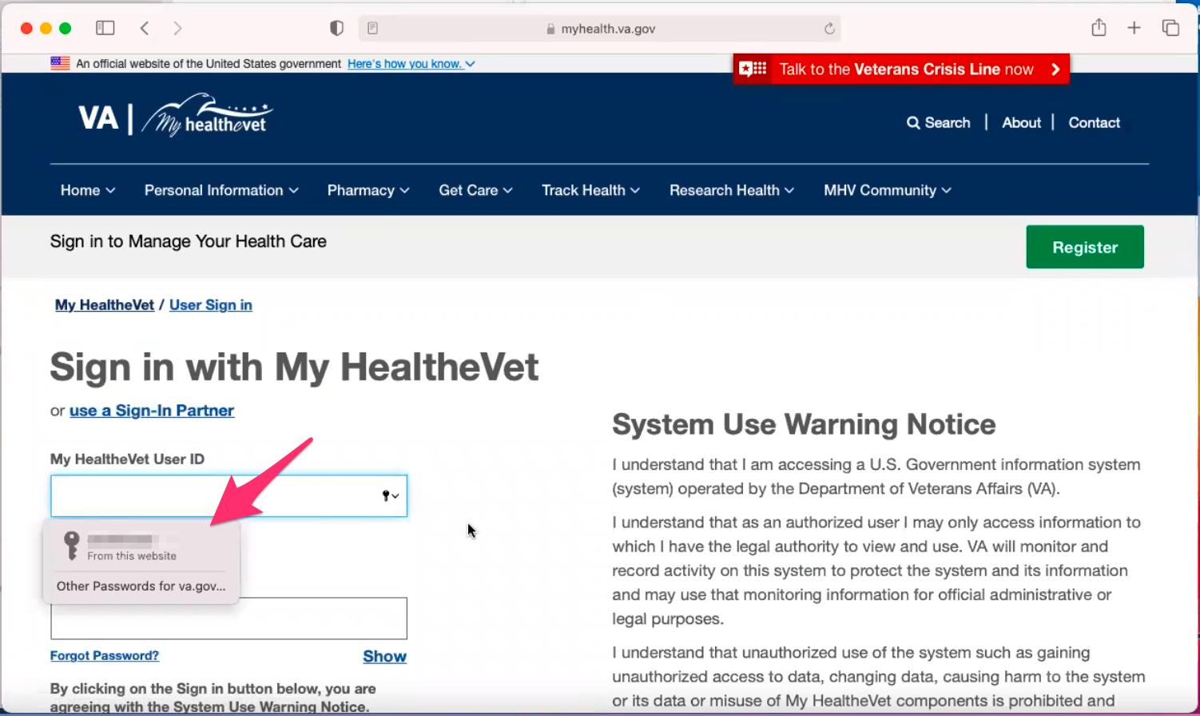

Veteran logs into site using saved user id and password in Safari.

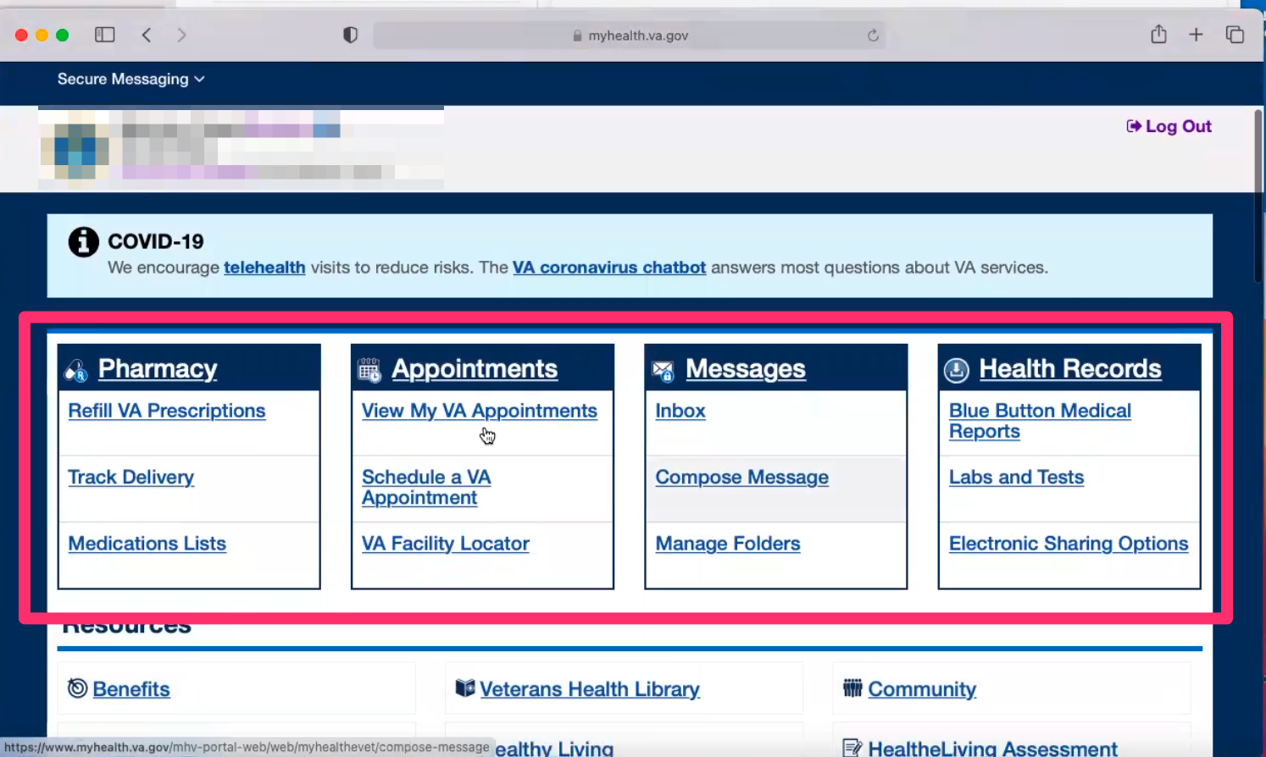

Page loads and Veteran scrolls down and points out Pharmacy, Appointments, Messages, and Health Records boxes/callouts on home page.

[Veteran]: This top bar has everything I need. *Participant is referring to Pharmacy, Appointments, Messages, and Health Records boxes/callouts on home page.*

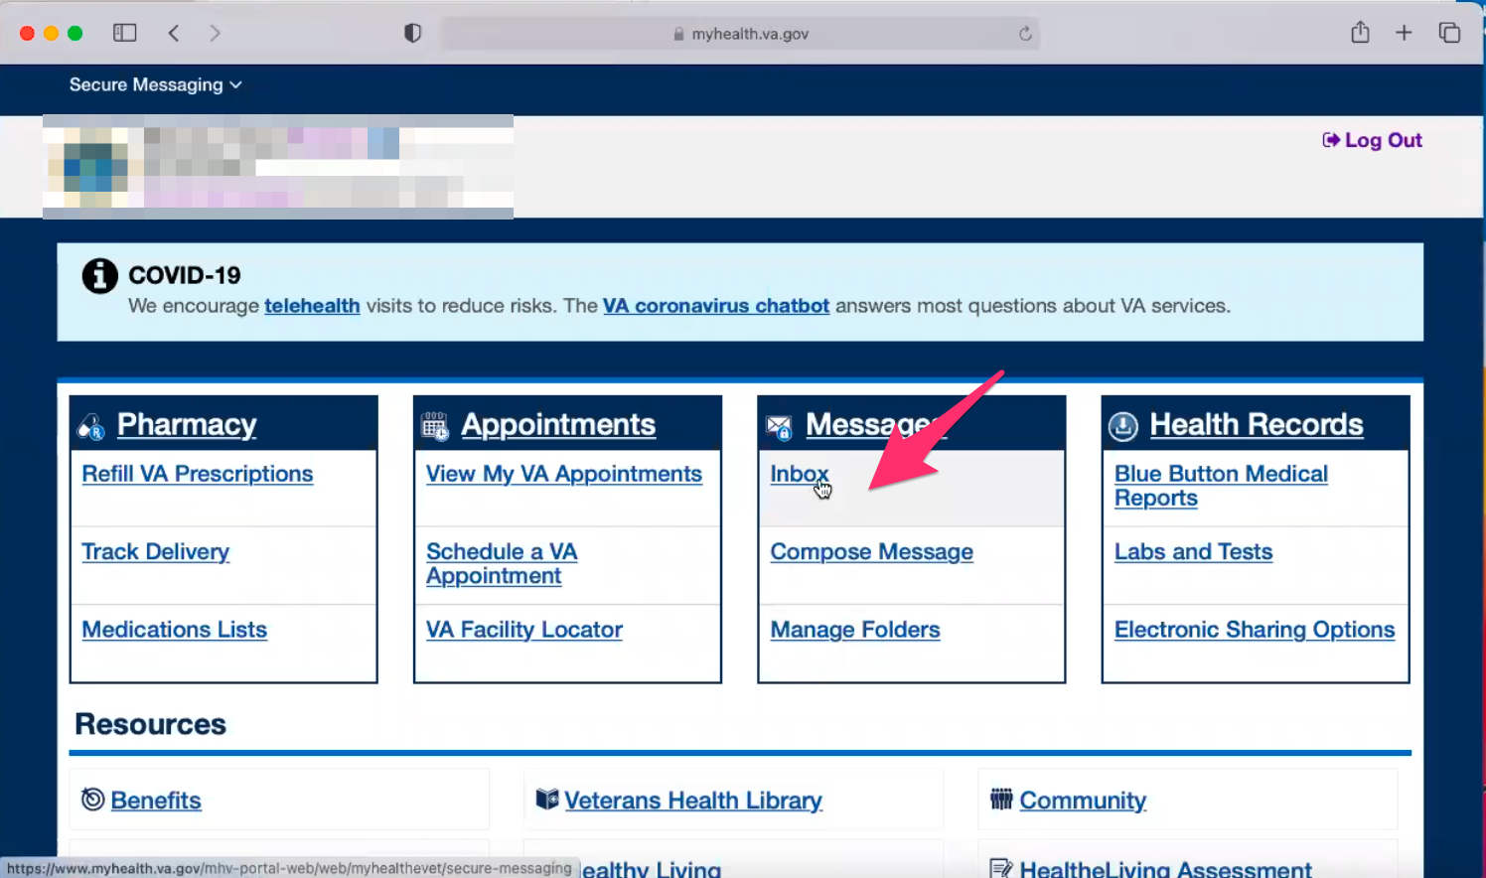

Veteran clicks on “Inbox” link in Messages box/callout on home page.

[Veteran]: I would go to inbox

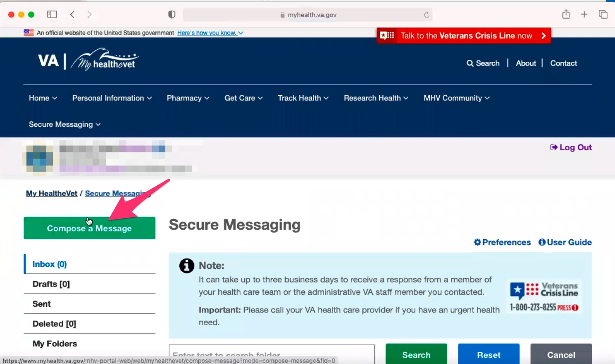

Secure Messaging page loads and Veteran immediately mouses over green “Compose a Message” button in upper left sidebar.

[Veteran]: And compose a message.

**How do you know there is a response:**

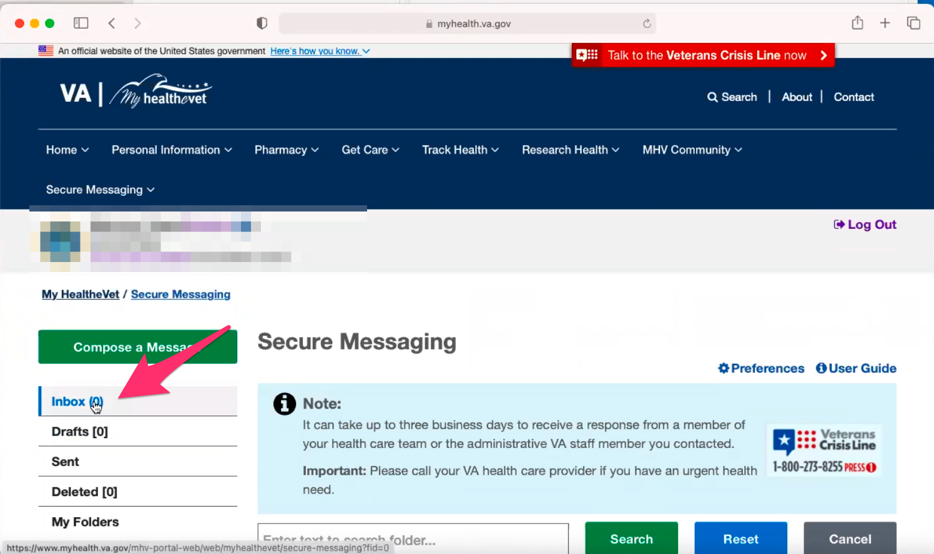

Veteran mouses over “Inbox (0)” link in left hand sidebar.

[Veteran]: This being zero 0 here becomes would be a number. Sometimes I get an email saying that I have response. Sometimes I don’t. So it’s not reliable to wait to the email.

**Something you have to log in to see:**

[Veteran]: Yes.

* **How would you refill a prescription [Veteran] have with the VA?**

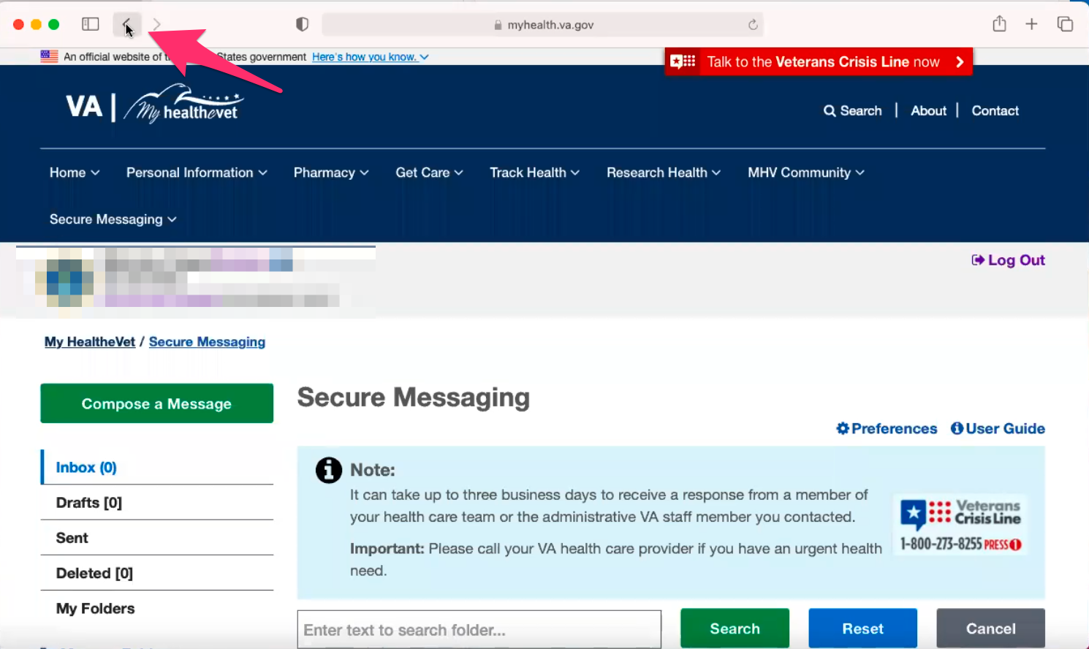

Veteran clicks on Safari browser back button to go to My HealtheVet home page.

On this screen again. *Participant is referring to Pharmacy, Appointments, Messages, and Health Records boxes/callouts on home page.*

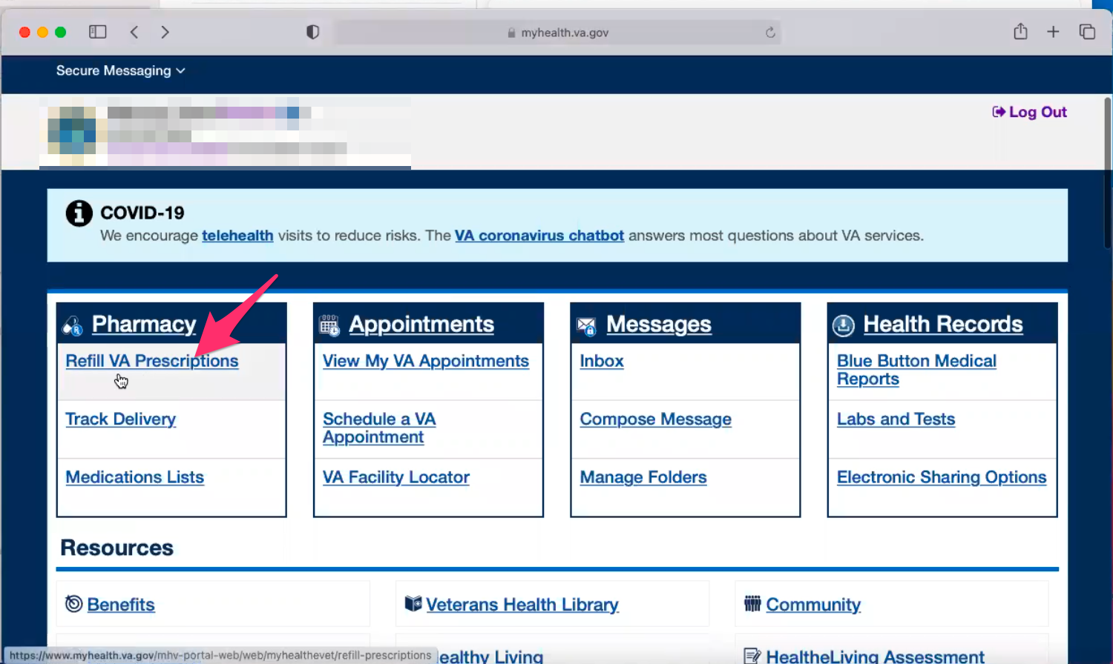

Page loads and Veteran points out Pharmacy, Appointments, Messages, and Health Records boxes/callouts on home page.

Veteran clicks on “Refill VA Prescriptions” link under Pharmacy box/callout.

[Veteran]: To refill VA prescriptions.

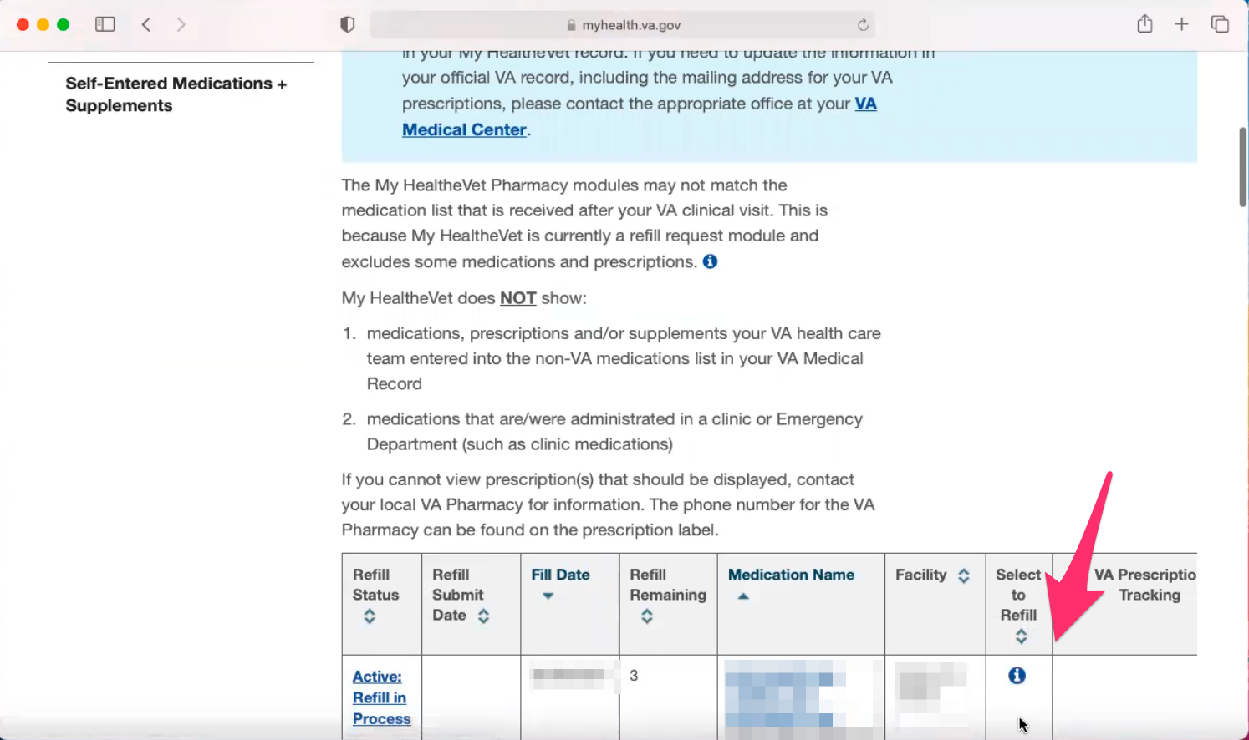

Refill VA Prescriptions page loads and Veteran immediately scrolls down to prescription table/list and points out where they would check a box to refill.

[Veteran]: Mom normally does this part. If there is a refill there is a click. There would be a box here you can click on.

**[Caregiver] have you had issues on this page before:**

[Caregiver]: I haven’t had any issues, it works fine for me.

* **Since you both use the account, how has the experience been sharing:**

[Caregiver]: No it is easy because if I see she needs something I tell her or I go to it.

[Veteran]: The password it already filled in.

[Caregiver]: Everything is set. If it’s been refilled the day before you can’t refill it again. So it makes it easier. *Participant seems to be suggesting that they can’t refill the same prescription if the each log in with a short period of time of each other.*

**You use the same computer:**

[Caregiver]:Yes it is easier that way.

[Veteran]: Sometimes I use my iPad but because it is another Apple device it is the same as being on the laptop.

**In terms of saving link and password:**

[Veteran]: Yes.

* **How about an appointment with [Veteran's] VA care team?**

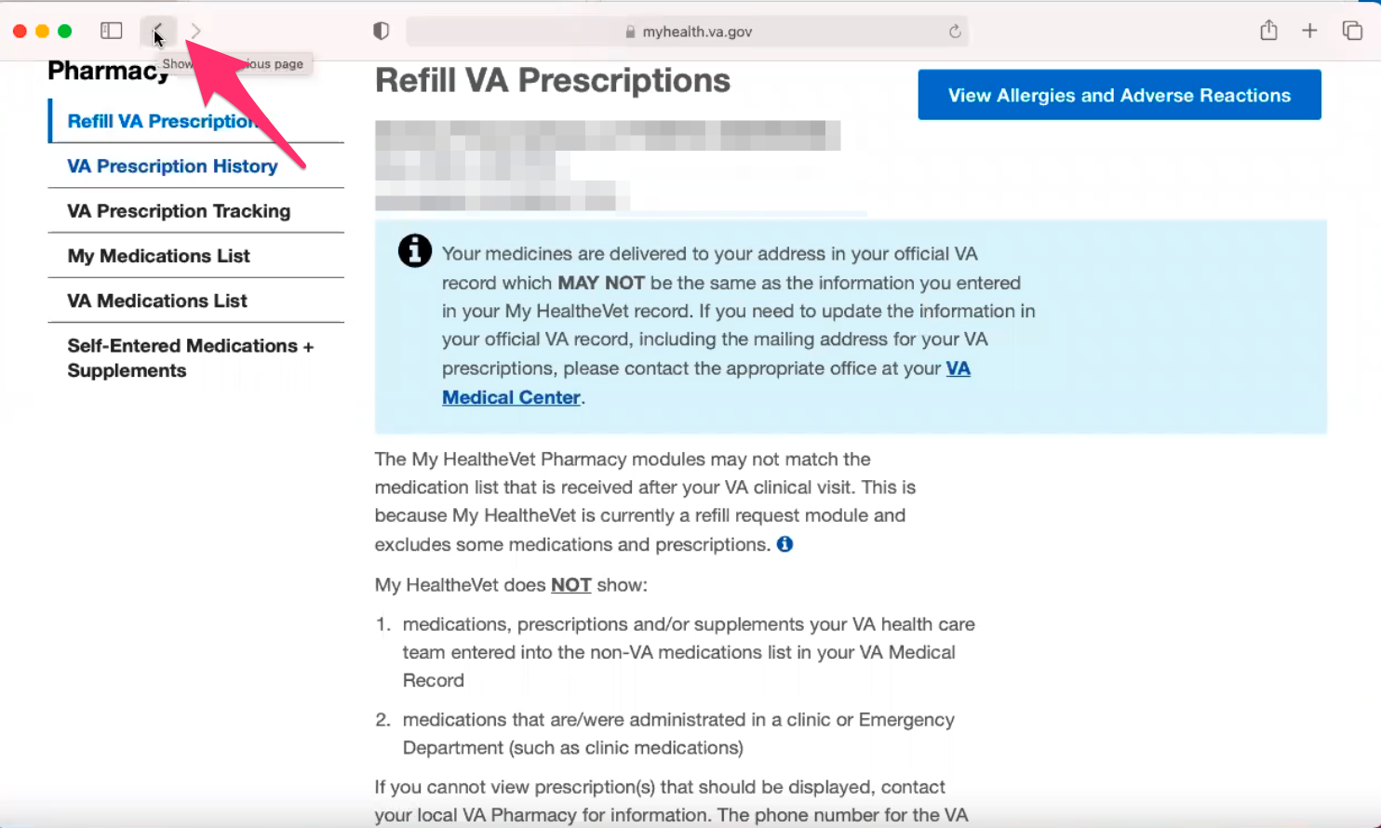

Veteran clicks on Safari browser back button to go to My HealtheVet home page.

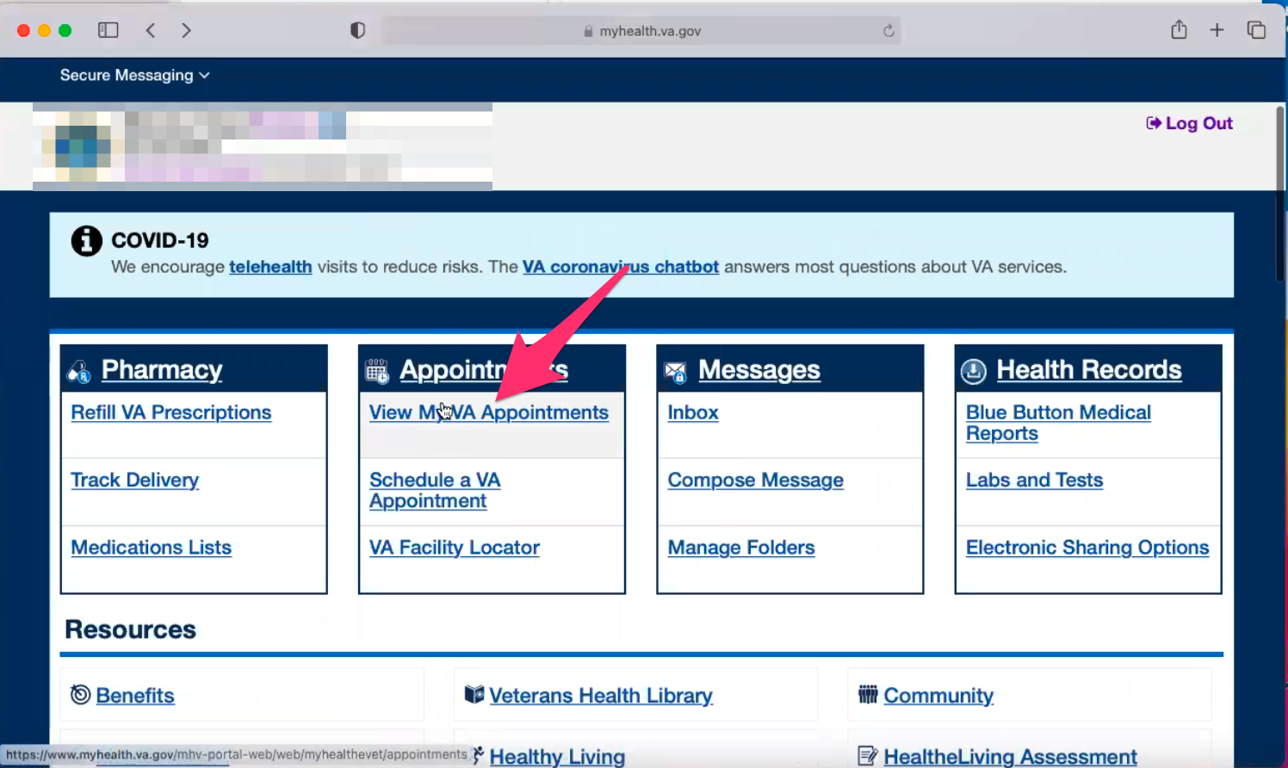

Page loads and Veteran points out Appointments box/callout on home page.

Veteran clicks on “View My VA Appointments” link under Appointments box/callout.

[Veteran]: Click on appointment. View my appointments.

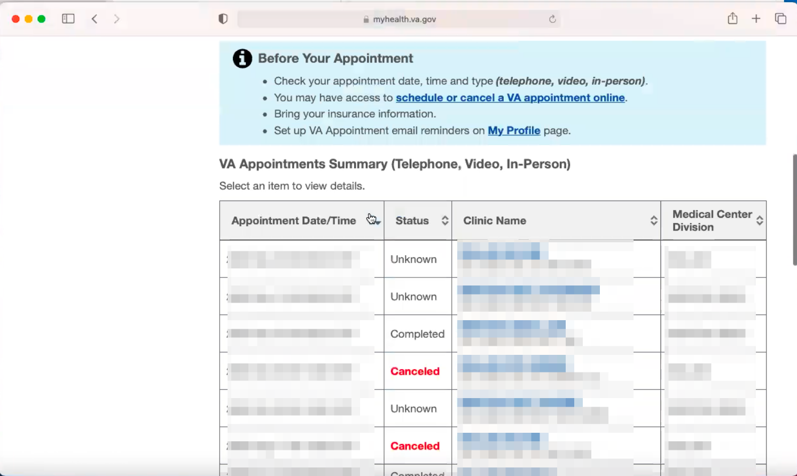

View My VA Appointments page loads and Veteran immediately scrolls down to appointment table/list.

And they are down here.

* **How do you check on a private provider outside the VA?**

[Caregiver]: Those are all logged into her calendar once we make the appointment, which has reminders a day or so in advance.

[Veteran]:We have a family calendar.

**Which calendar do you use:**

[Veteran]: The google calendar.

**Do you add VA appointments to it too:**

[Caregiver]: Yes everything.

* **Have you ever had to pay a copay to the VA?**

[Veteran]: No.

[Caregiver]: No.

* **Have you ever had a reimbursement from the VA for traveling to [Veteran's] health care appointments?**

[Veteran]: Yes we did.

[Veteran]: We did it when we went to Dallas because the Denton one is too close. They have little kiosks set up inside the VA. And when you check in and then they scan your card. You say yes you drove and check the address and then you click submit. Then you get reimbursed in a little bit.

* **Do you have any dependents on [Veteran's] VA benefits?**

[Veteran]: No.

* **I know you mentions your dad is retired military, are you a dependent on his:**

[Veteran]: No just on my own.

* **How do you login to ebenefits for records:**

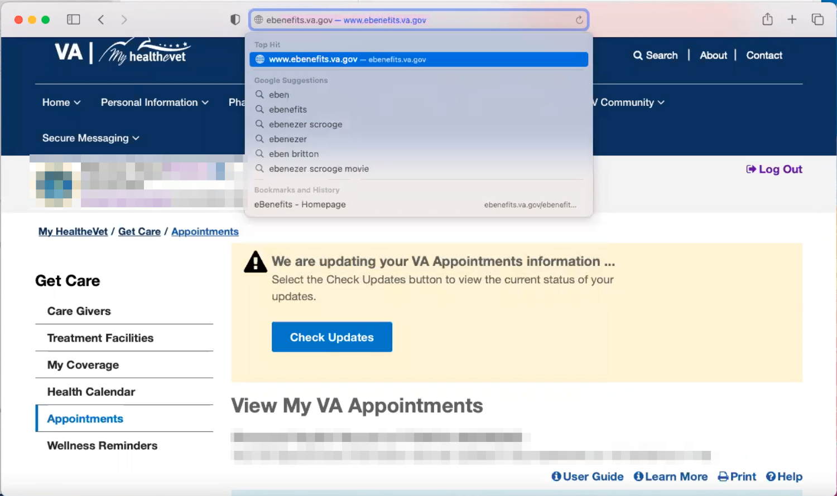

Veteran types in “ebe” in Safari url/search bar and clicks on [www.ebenefits.va.gov](http://www.ebenefits.va.gov) Top Hit result.

[Veteran]: Here is where I would apply.

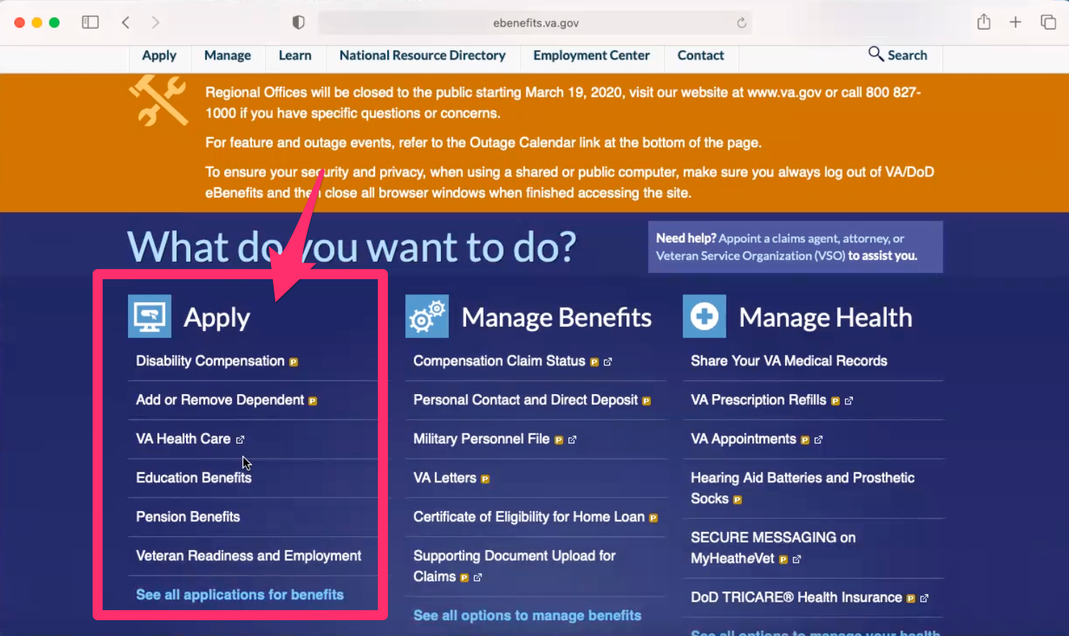

Ebenefits site loads. Veteran scroll down page and points out Apply section on home page.

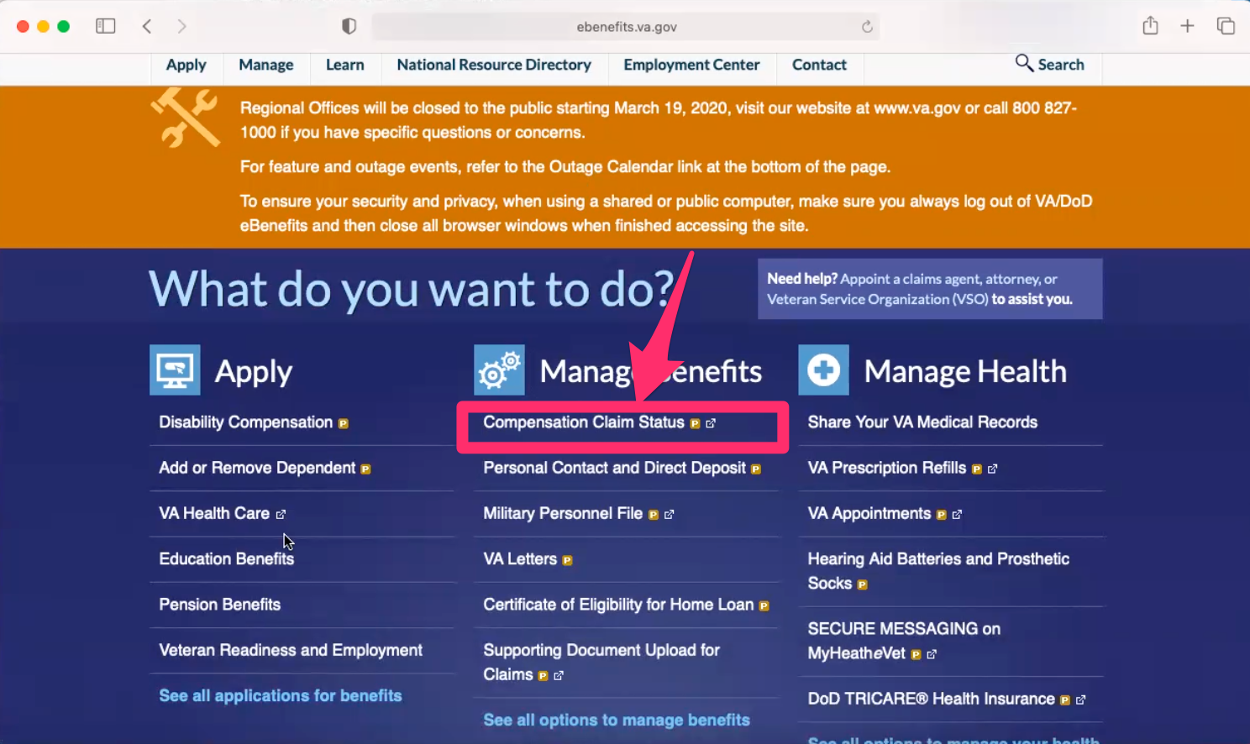

Veteran points out “Compensation Claim Status” link under Manage Benefits section on home page.

[Veteran]: Here I could check my claims.

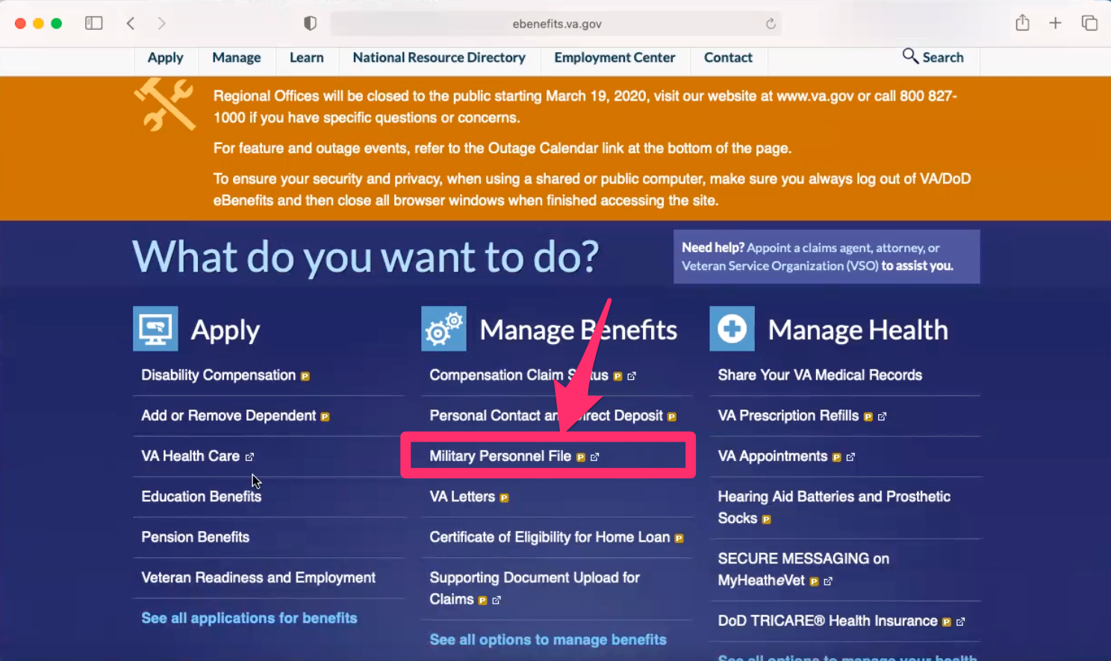

Veteran points out “Compensation Claim Status” link under Manage Benefits section on home page.

[Veteran]: This must be new. I’ve never seen this before. *Participant is talking about Military Personnel File link under Manage Benefits.*

[Veteran]: This what I was talking about getting my letters.

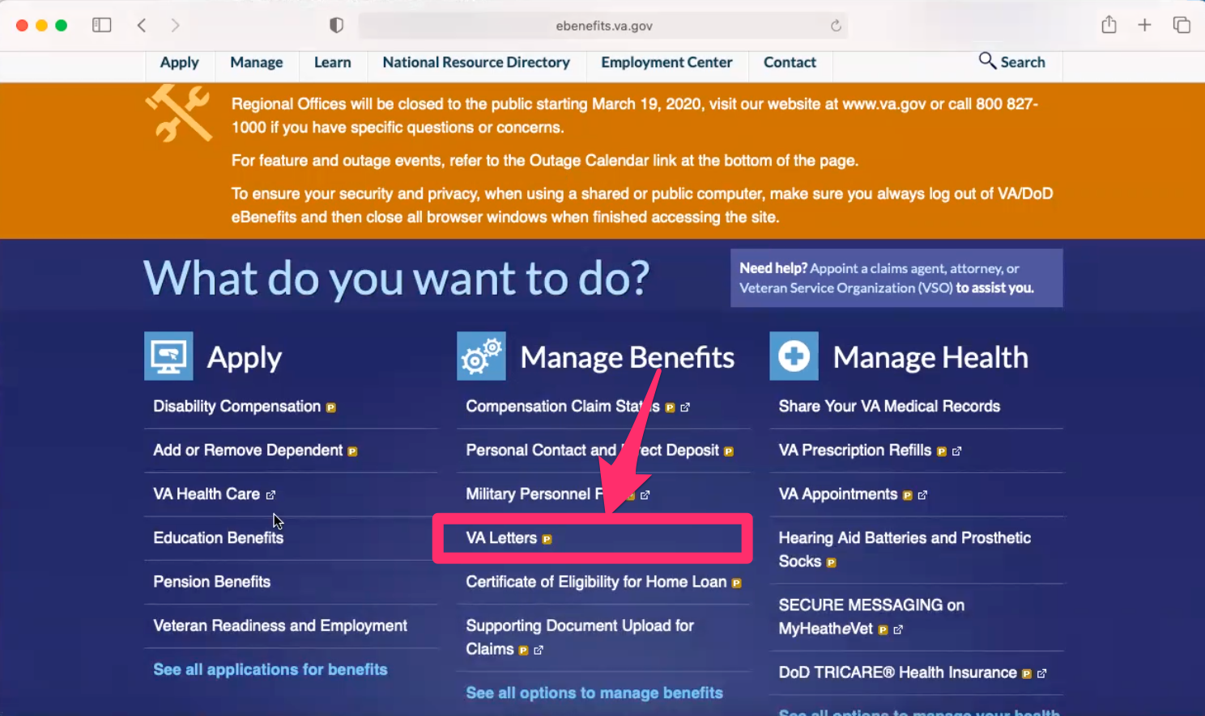

Veteran points out “VA Letters” link under Manage Benefits section on home page.

I have never used theses [Manage Health] links because I just go to My HealtheVet site.

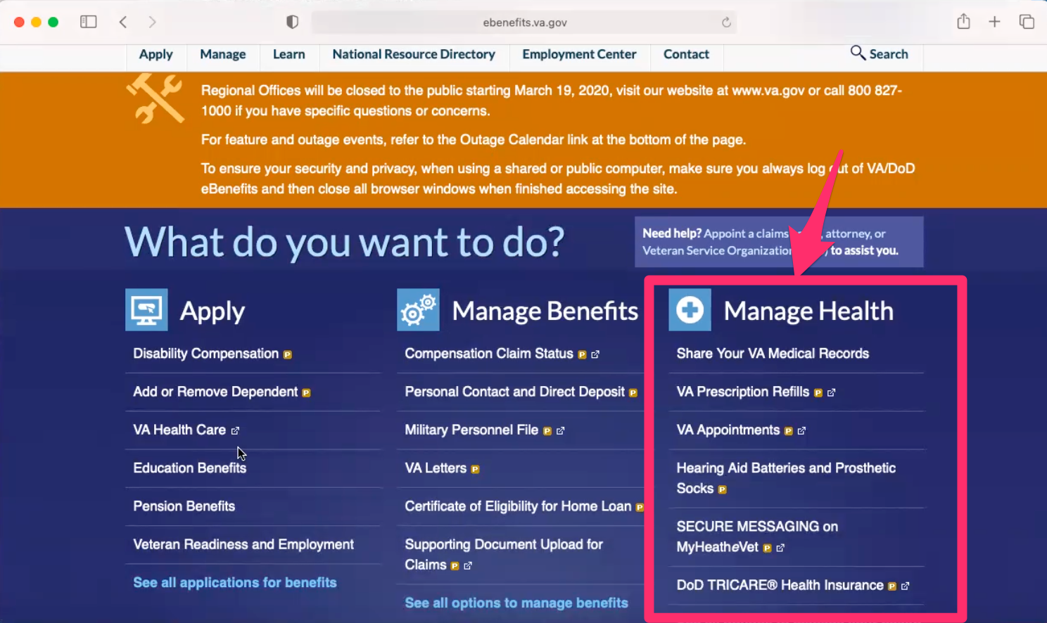

Veteran points out Manage Health section on home page.

**Branding and trust (5 minutes)**

Now I’d like to ask for your thoughts on My HealtheVet. (Confirm that participant has used My HealtheVet previously. If not, amend questions below to capture their first impressions while looking at a logged in account.)

1. **On a scale from 1-5, with 1 being very dissatisfied, and 5 being very satisfied, how satisfied are you with My HealtheVet?**

[Veteran]: I feel like a 4. It’s a pretty decent site. It makes it easier to get things done with the VA.

[Caregiver]: I would say the same.

1. **On a scale from 1-5, with 1 being very low, and 5 being very high, how would you rate your trust in My HealtheVet?**

[Caregiver]: Well since it is just medication and talking to the doctor it is okay. I trust that I will get the medication because they haven’t failed yet. And we are always able to talk to her doctor.

[Veteran]: I would say it is a 5. I mean it hasn’t steered us wrong yet.

**My HealtheVet patient portal (15 minutes)**

Let's take a look at My HealtheVet together.

Moderator will ask participant to share screen if not already, or show logged in My HealtheVet account. **(5 minutes)**

1. **What do you use this website for the most?**

[Veteran]: I use to talk to my doctors and my mom uses it for the meds the most.

[Caregiver]: Yeah the meds.

1. **What do you find the most valuable on this website?**

[Caregiver]: The medication part.

[Veteran]: I guess because I use it to contact my doctor or my doctors the nurse quickly. If you call in you don’t get them. You get someone who has to get a message to them.

[Caregiver]: True.

1. **What do you wish this website did that it doesn’t do right now?** [Caregiver]: Right off hand. I can’t think of anything.

(If time allows) While we're here, I’d like to get your feedback on a couple of sections on this website. **(10 minutes)**

1. **Get Care**

* **Have you used any of the sections under "Get Care” that you have used before.**

[Veteran]: Not me.

[Caregiver]: No not really. I just normally go to the same old spots I have always gone.

* Click on Treatment Facilities. What are your first impressions of what this page is doing here:

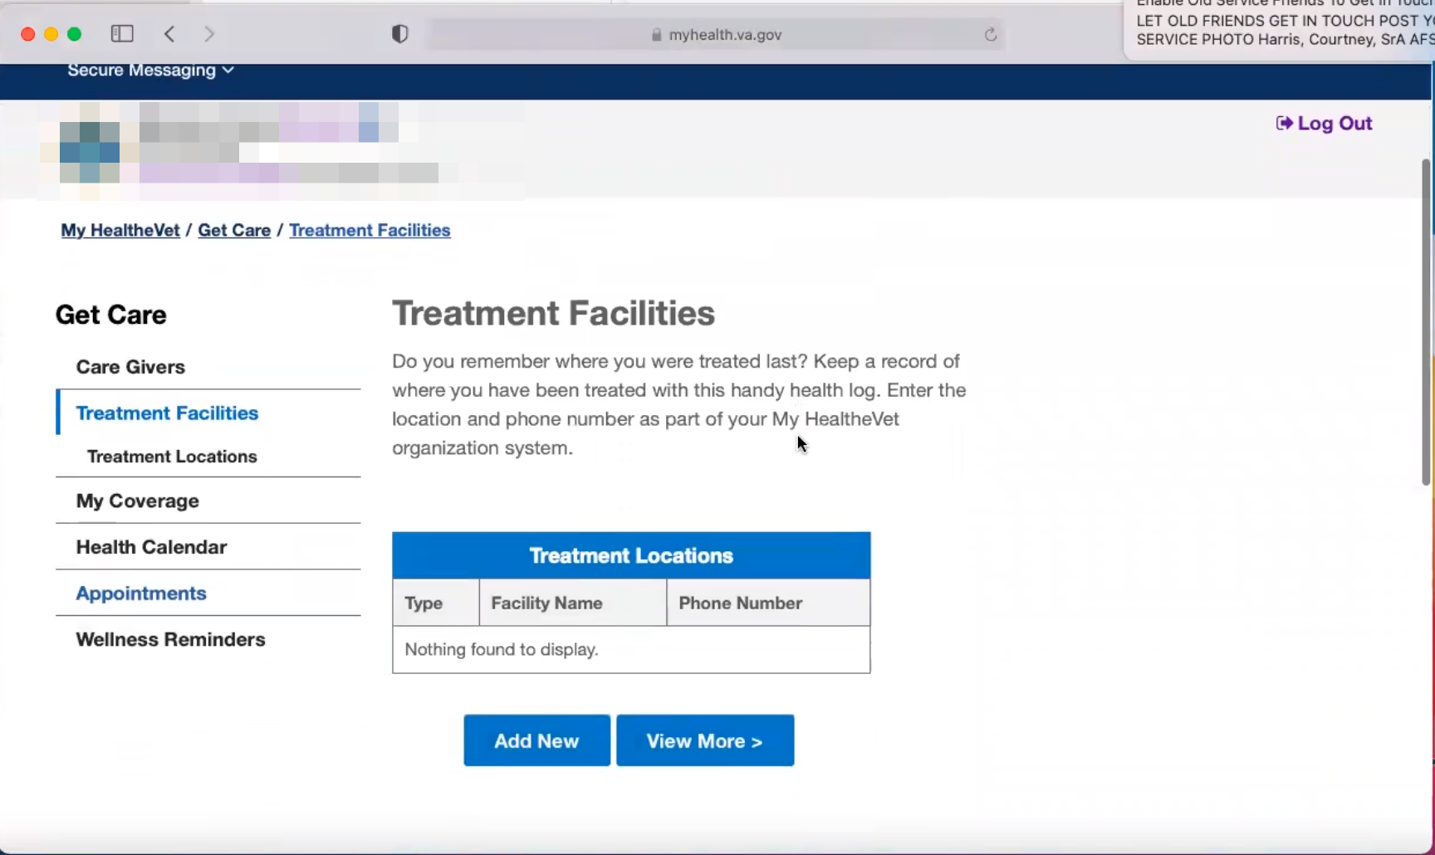

Treatment Facilities page loads and Veteran scrolls down.

[Veteran]: Oh. You are supposed to fill in where you saw the VA. Which VAs you are going to. I don’t know why I would do that. Participants think about it for several seconds.

**So you don’t know why you would do that:**

[Caregiver]: No. Because we basically stick to the same ones. It’s not like I would need to look to see where she got treatment at. When we went to Houston we went straight to the Houston VA. And here everything is in the Denton annex. If we have do her neurologist it is at the Dallas main facility. Its not like we go to different places we stick with the same ones. I don’t see where we would use that.

* **Click on Health Calendar [link in left hand sidebar]. Curious have you seen this before or used it:**

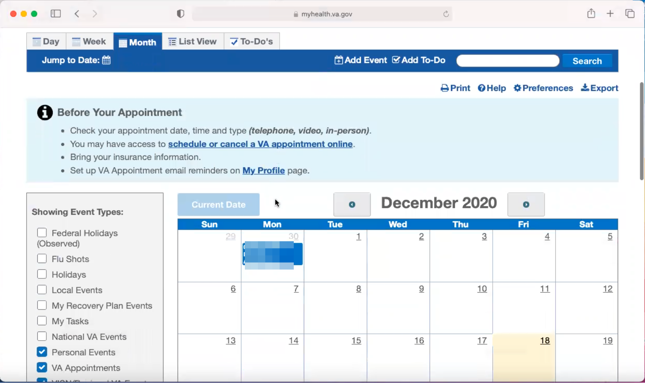

Health Calendar page loads and Veteran scrolls down.

[Veteran]: Oh hey look at that. Hmm. *Participant seems to be intrigued by this page.*

[Veteran]:No we haven’t used it but it looks like our calendar except ours is all filled in.

[Caregiver]: Our calendar is filled from morning to night.

*Veteran shares view of Mac Calendar App to show.*

**Would this be something you’d use:**

[Veteran]: If we had known about this before. The only thing I don’t like is that you have to login to a website rather than just an app that just opens. What if I don’t have internet connect.

[Caregiver]: Whereas having an app on the phone she keeps it with her at all times so she won’t miss an appointment or medication. Because it will buzz her until she does it. There’s no off switch for her alarms I set for her meds.

**Thank you and closing (2 minutes)**

**Feedback**:

[Veteran]: I think the big takeaway of the VA system is that it is very dependent on which VA you go to.

[Caregiver]: Yes.

[Veteran]: If you had asked us a year ago we would have had nothing but bad stories for you. But now that we are here our story is totally different. So it is dependent of which VA you go to.

[Caregiver]: I look at it as big city and country life. Big city you don’t get anything. Country life you get more. A lot more hands on in the country.

**Feedback as a caregiver:**

[Caregiver]: The VA needs to be more caring and listen more to the actual caregiver.

[Caregiver]: I really had to stress my point to the doctors in the beginning as to what was happening and what she needed for her everyday life.

[Veteran]: If my caregiver speaks that should be enough.

[Caregiver]: When I asked for things they would just be like why. Well this is what she needs and how it could benefit her.

[Veteran]: Or worse they would look at me to double check. And especially back then I was spaced out so I didn’t know if they were trying to say don’t take advantage. But they made it hard on her even after she had a power of attorney medical wise.

[Caregiver]: As for the caregiver program they should be a better way to evaluate what care needed for the Vet before setting a tier level. Because basically the stuff I do for her isn’t covered under caregivers on an everyday base.

[Veteran]: Well it’s covered but not to the extent and it is hard to get them understand. I don’t have a terminal illness but I need my mom 24/7. She gets up in the middle of the night to check on me and they shouldn’t compare illnesses or injuries. They should compare what they do for you.

[Caregiver]: Because it started with her mental condition they had me down for and that wasn’t even the main issue. The main issue was I get her dressed, I get her up, I feed her. That’s what I mean they need a better way to evaluate.